Bellevue Slim Wall Hung Vanity

**Product Code:** K93RW-CO / K93RW-PO

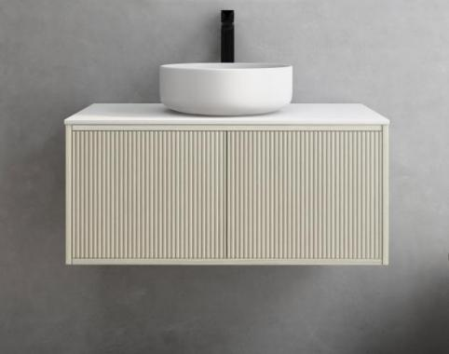

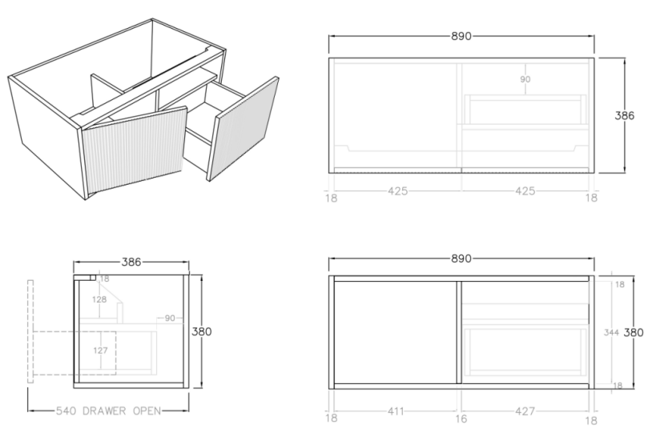

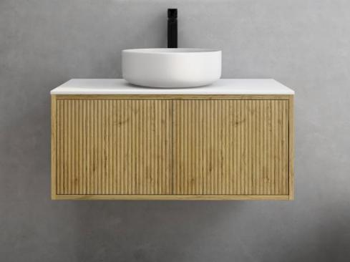

**Specification:**

Material: MDF construction

Finish: Coastal Oak / Prime Oak

Dimension: 890*386*380mm

Slim door / Right hand drawer

Woodgrain thermolaminated V-Groove Push-to-open drawer with internal storage shelf

Box Trap & Space Saver Kit 40mm recommended (35122)

Vanity top options:

Stone top (with choices of tap hole and waste hole position) -

Quartz (-QST): ABW939

Natural Marble (-MST): ACar939 / ANmq939