Bellevue Slim Wall Hung Vanity

**Product Code:** K73W-CO / K73W-PO

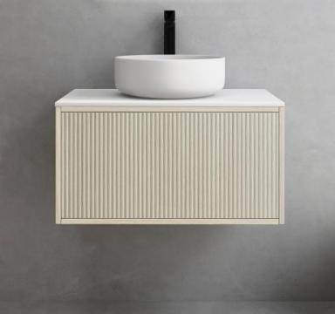

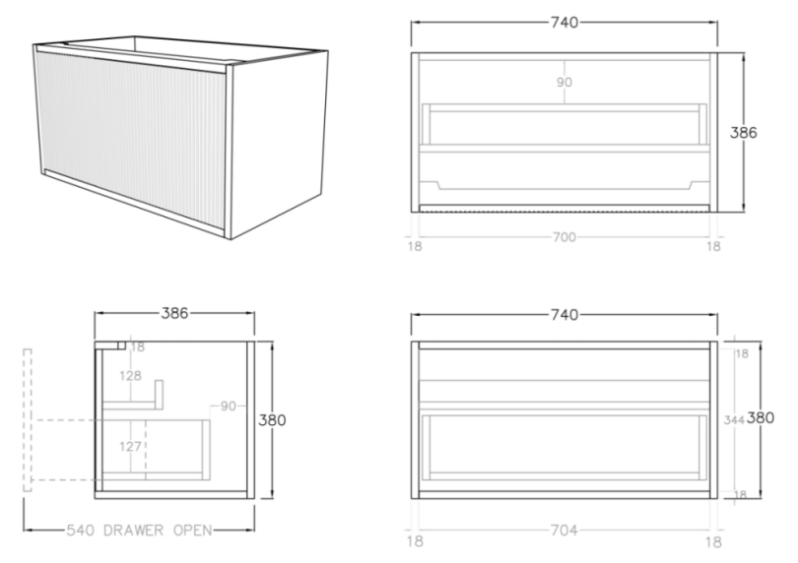

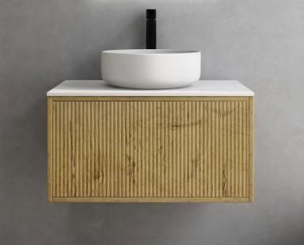

**Specification:**

Material: MDF construction

Finish: Coastal Oak / Prime Oak

Dimension: 740*386*380mm

Woodgrain thermolaminated V-Groove Push-to-open drawer with internal storage shelf

Box Trap & Space Saver Kit 40mm recommended (35122)

Vanity top options:

Stone top (with choices of tap hole and waste hole position) -

Quartz (-QST): ABW739

Natural Marble (-MST): ACar739 / ANmq739

<https://www.poseidonbk.com.au/products/ceto/bellevue-vanity/bellevue-ensuite-slim/k73w/>