Bellevue Slim Wall Hung Vanity

**Product Code:** K153W-CO / K153W-PO

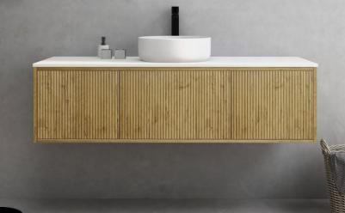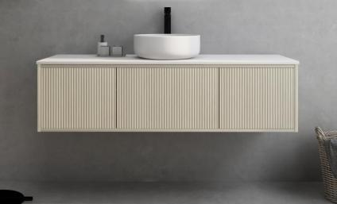

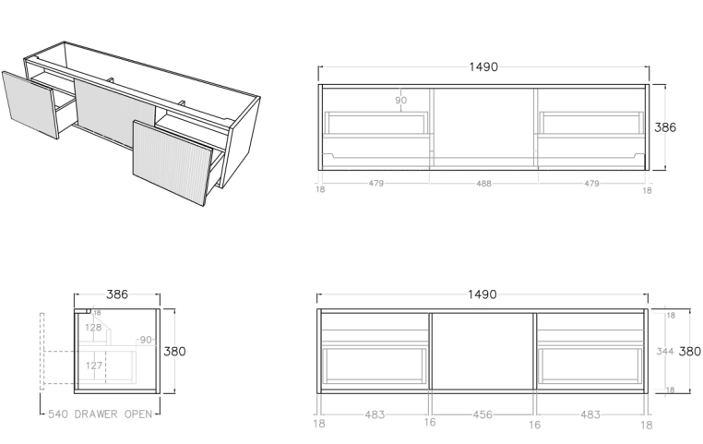

**Specification:**

Material: MDF construction

Finish: Coastal Oak / Prime Oak

Dimension: 1490*386*380mm

Woodgrain thermolaminated V-Groove Push-to-open drawer and Slim door withinternal storage shelf

Box Trap & Space Saver Kit 40mm recommended (35122)

Vanity top options:

Stone top (with choices of tap hole and waste hole position) -

Quartz (-QST): ABW1539

Natural Marble (-MST): ACar1539 / ANmq1539

<https://www.poseidonbk.com.au/products/ceto/bellevue-vanity/bellevue-ensuite-slim/k155w/>